**HOMEWORK 4**

Problem 1.

Create a Web Page like the following.

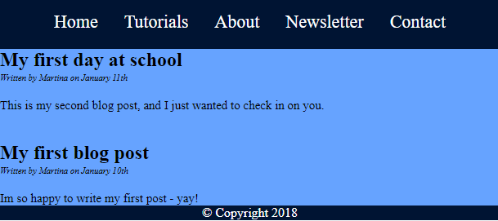

Create two files: "**simple-website.html**"and"**simple-website.css**".

### Constrains

* **Use the html and css from previous two problems**
* <footer> tag
  + Header and Footer Background color: **#001433**;
  + Body Background color: # 66a3ff;
  + <p> tag for text
  + Text Color: #fff;
  + Center the text

Problem 2.

Create a Web Page like the following

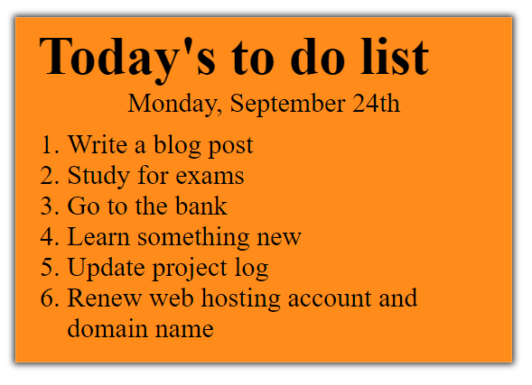

Create two files: "**to-do-list.html**" and "**to-do-list.css**"

### Constraints

* **<div>** with **class="my-list"** as container
  + Background color: **#ff8c1a;**
  + Padding: 8px 24px;
  + Width: 500px;
  + Text size: 30px;
  + Border: 1px solid #ffa64d;
  + box-shadow: 0 0 10px 2px #333333;
* <ol>
  + Margin: 12px;
* <p>
  + Center the text

Problem 3.

Create a Web Page like the screenshot below.

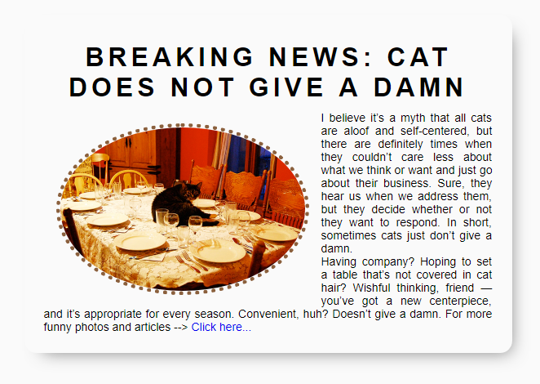

Create two files: "**simple-article.html"** and **"simple-article.css".** Use **semantic HTML** to create HTML the page.

### Constraints

* <body>
  + font-family:"Lato", sans-serif;[**"https://fonts.googleapis.com/css?family=Lato:300,400,900"**](https://fonts.googleapis.com/css?family=Lato:300,400,900)
* Content
  + Width: 550px;
  + Border radius:15px;
  + Center the content
  + Padding: 25px;
  + Background color: #fafafa;
  + box-shadow: 10px 11px 35px -14px rgba(0,0,0,0.54);
* <h1> tag for heading
  + Margin bottom: 0;
  + Padding: 10px;
  + Text center
  + Letter spacing: 5px;
* **Image**
  + Width: 200px;
  + Border radius: 50%;
  + Margin: 15px;
  + Border: 5px dotted #8b603d;
  + Use “**left floating**” for the image: <https://css-tricks.com/almanac/properties/f/float/>
* **Paragraphs**
  + Text size: 14px;
  + Use “text-align: justify” to align the text left and right (learn more at <http://www.w3schools.com/css/css_text.asp>).